Market Maker Trap Head Shoulders Pattern

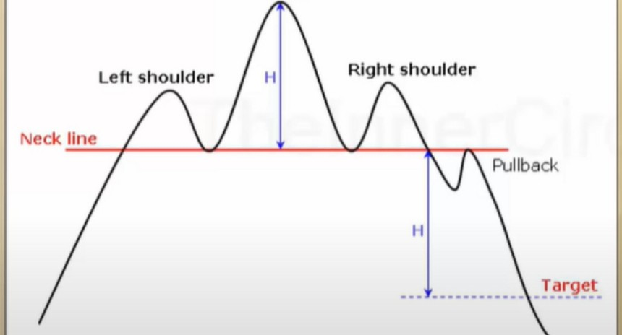

Head & Shoulders Pattern

Head and Shoulders

Head

Generally price will form these genuinely at intermediate or long term highs.

Due to the low understanding of most Retail Traders - they seek this classic topping pattern on lower timeframes.

Many times at a significant low in price - but they marry the pattern.

|  |  |  |
| --- | --- | --- |
|  |  | Inverted  Head & Shoulders Pattern |
|  | Generally price will form these genuinely at intermediate or long term lows.  Due to the low understanding of most Retail Traders - they seek this classic bottom pattern on lower timeframes. |
| Head |  |
| Inverted Head & Shoulders | Many times at a significant high in price - but they marry the pattern. |

# Picking tops and bottoms is the worst thing you can try

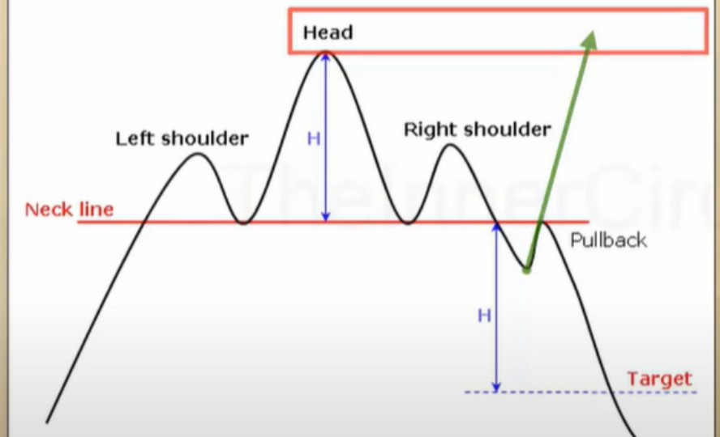

H ad & Shoulders Pattern

Head and Shoulders

Generally price will form these genuinely at intermediate or long term highs.

Due to the low understanding of most Retail Traders - they seek this classic topping pattern on lower timeframes.

Many times at a significant low in price - but they marry the pattern.

|  |  |  |  |
| --- | --- | --- | --- |
|  | lnvened Head & Shoulders |  | Inverted  Head & Shoulders Pattern  Generally price will form these genuinely at intermediate or long term lows.  Due to the low understanding of most Retail Traders - they seek this classic bottom pattern on lower timeframes.  Many times at a significant high in price - but they marry the pattern. |

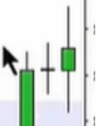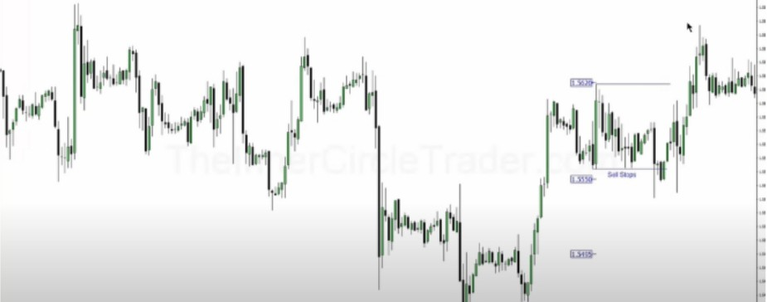1h TF

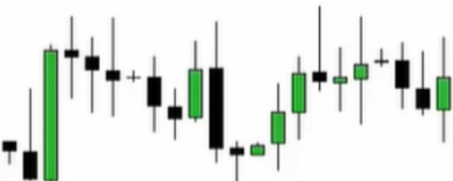

.I.

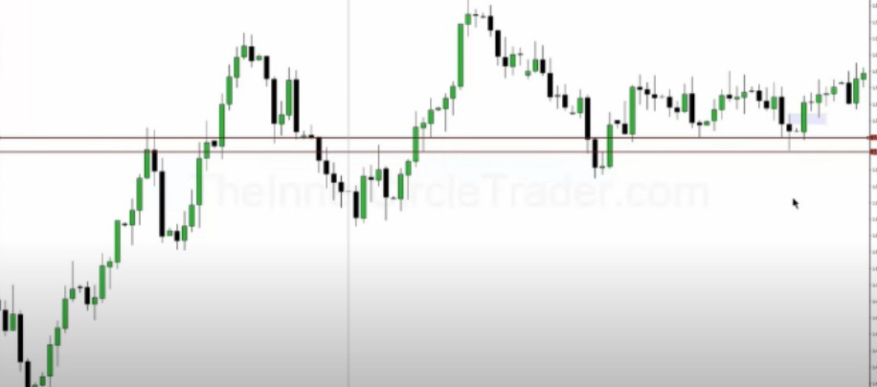

# Daily TF

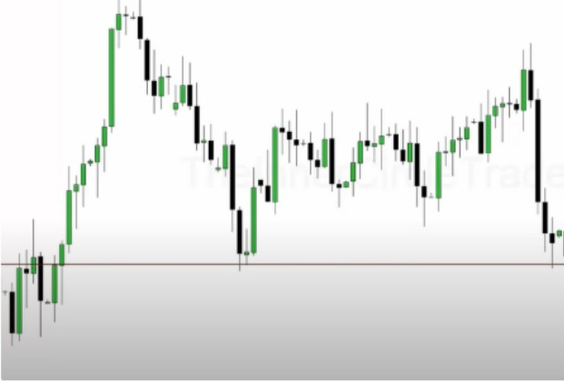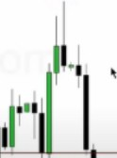

..

..

II·

,I I •:

1.1

I,

1•1. 1·,1

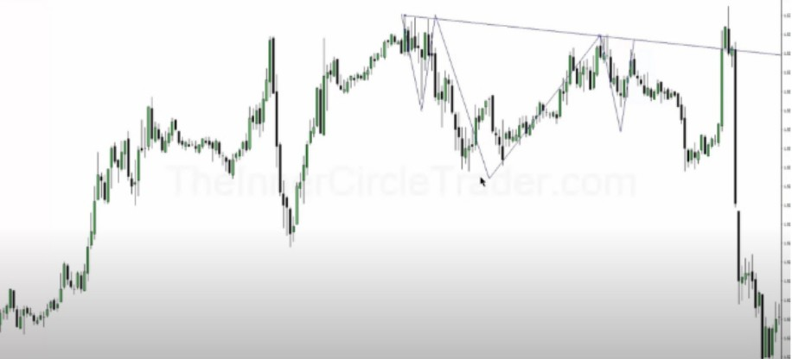

## Arjo I Twitter, lnstagram I Linktree

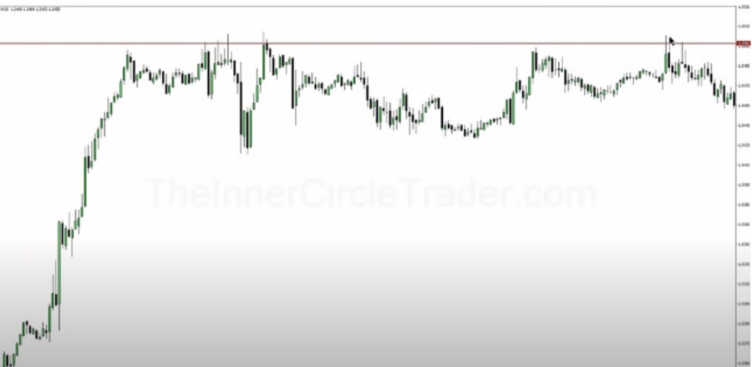

Linktree. Make your link do more.

, https://t.co/HhmmTN1fUI

## JavaScript is not available.

*"JI* https://twitter.com/arjoio